**PROJECT ON WEBSITE DEVELOPMENT**

INTRODUCTION:

Overview:

Online shoping is very popular which brings everything to Home.Now days due to covid people unable to go out and buy their needs.So ,online shoping is also best way to buy products from home.

Purpose:

The best in my website is you can buy products like clothing,accessories which is every useful along with all brand s .

The website I developed was “FASHION” which has unquie styles and various brands and copouns are applied with reasonable prices as we are customing the products.

LITERATURE SURVEY:

I got command on wordpress and learned to design a website in easy mannner ,the most liked is elementor plugin .While building website ,came with many ideas to develop website.

Existing problem:

As already mention we can buy the product at any time at any place .now a days people are busy in their works and lazy ,they dont have time to go out and buy the things.

Proposed problem:

So,I brought up a fashion website where anyone can buy the products from any place at any time and product is delivered to our respective address.

THEORITICAL ANALYSIS:

Diagrammatic overview of project:

Select the category or you click on search option

You can view all the categories like women,men

Go to the home page

Browse the website Fashion

Then you can add to cart and buy the product.

Click on the images with name label you can view product

Hardware /Software Desinging:

Software used is wordpress ,

Elementor plugin,

SQL ,

Apache.

EXPERIMENTAL INVESTIGATION:

By using wordpress and especically elementor plugin made my work easy and consumption of time is also less.I learnt how to build a website ,who to host ,migration concepts .

According to the solution ,you access the website and buy your fashionable clothes in Fashion ..

FLOWCHART:

Search on console provided

Go the website Fashion website

Click on the home

You can add to the cart and buy the product by using details

Select the category images and click on image(click on handbag image )

Go to category like men or women

Add payment and pay the money

RESULT:

This is my website home page .

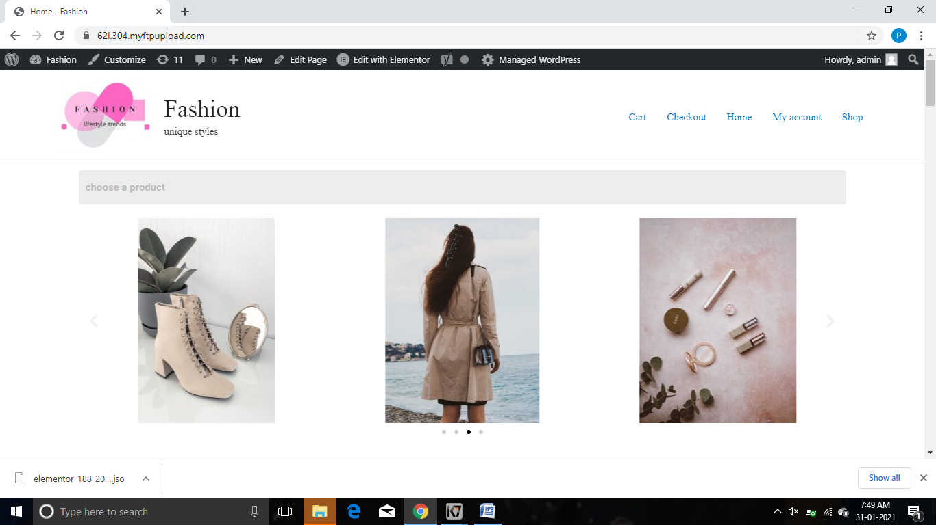

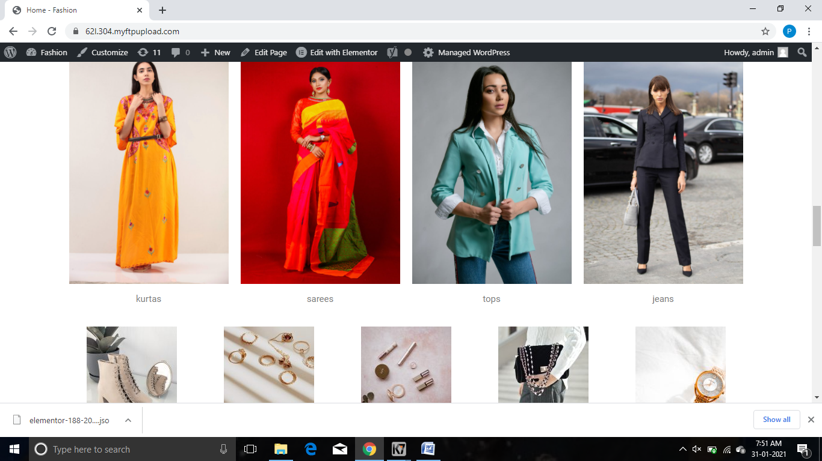

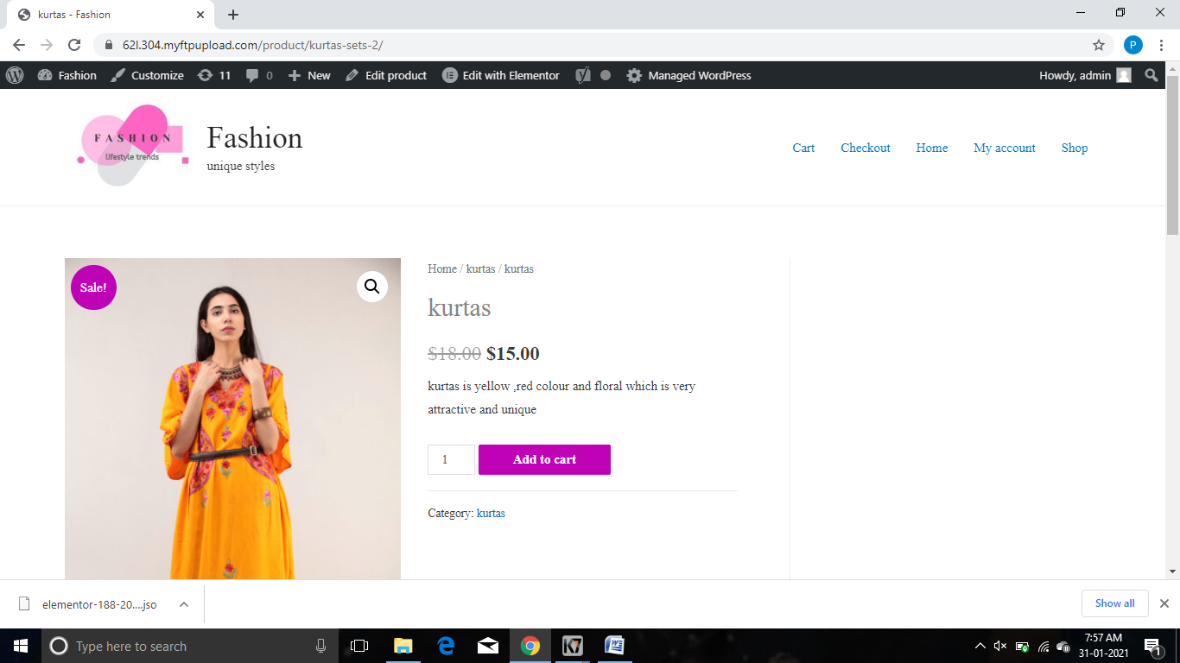

ADVANTAGES:

* At any place at any time we can place a order
* Reasonable prices
* Best brands
* Delivery is quick

DISADVANTAGES:

The disadvantage is matching accesories and clothing to explore fashion.need to work on it.

Remaining are perfect you can access and buy the products are avaliable.

APPLICATIONS:

* Every indiviual can order the product and buy the product
* Any time you can buy the product
* You can view all the famous brands at one place.

CONCLUSION:

Website for online shopping Fashion is build you can order and buy the products.

FUTURE SCOPE:

Online shopping has more scope in future,now a days people are very interested in buying products from online.